**Choukri, Mohamed (1935-2003)**

SUMMARY

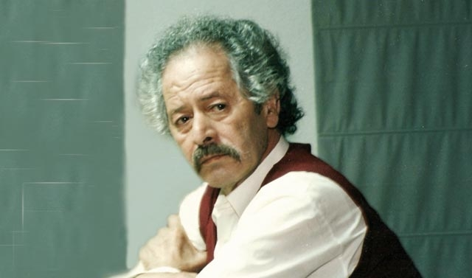

Mohamed Choukri, <http://www.jadaliyya.com/pages/index/19163/mohamed-choukri_a-profile-from-the-archives>

Mohamed Choukri (Muḥammad Shukrī محمد شكري) was a Moroccan writer who made an important contribution to the renewal of literature in the Arabic world. Internationally, he is one of the best-known Arab writers, mainly due to his relationship with Paul Bowles, who was his mentor and translator into English. Choukri introduced major changes in Arabic literature, in terms of both the topics selected and the language used, combining classical Arabic with the Moroccan dialect. His main literary corpus is autobiographical and draws on his inspirational life: born in truly miserable conditions, he managed to educate himself and obtain a university degree before becoming a teacher and writer. The first volume of his memoirs, *For Bread Alone*,is one of the most widely read books in Arabic, and was even adapted for the cinema.

MAIN ENTRY

Mohammed Choukri was born in the Moroccan Rif in 1935, then under the Spanish Protectorate of North Africa. He spent his childhood in abject poverty, suffering severe misery and hunger. He ran away from his family and his despotic father and worked in many different jobs to earn a living until he graduated as a primary school teacher. Eventually, he retired from teaching and lived devoted to writing.

He met Paul Bowles in Tangier, where both men were living. Bowles acted as a sponsor of many young Moroccan story-tellers, such as Mohamed Mrabet, for instance, since he admired the combination of oral tradition and fresh stories that they told. He also helped Choukri at the beginning of his career, and in fact Choukri was the only one of his protégés who can be considered a real writer. Choukri had written *For Bread Alone* in 1972 but he could not find an Arabic editor; the English translation (1973), by Bowles, opened the door to the English reading world. Some years later (1980) Tahar Ben Jelloun translated the work into French as *Le Pain Nu*, which was also a major success. The book was finally published in Arabic in 1982 but until 2000 was still censored in Morocco due to its explicit sexual and violent scenes. The book is a graphic autobiographical depiction of his life as a homeless child in Tétouan and Tangier, surrounded by prostitution, drugs, and corruption of all kinds.

In Tangier, Choukri also met other great writers such as Tennessee Williams, Jack Kerouac, and Jean Genet, and recorded his experiences with them in several diaries such as *Jean Genet, Tennessee Williams in Tangier*. He was also a literary critic and wrote several articles on his views on the role of the writer and his engagement with the society around him.

Although he wrote novels, short stories and plays, Choukri’s most important work is his autobiographical trilogy. Besides the first volume, *For Bread Alone*, he published *Time of Errors* (1992)and *Faces* (1996).

Choukri’s style is realistic, with the use of short, direct sentences to emphasize meaning. His vocabulary reflects the brutality of the experiences of poor people, and includes terms that were usually considered unsuitable for literature. In his work, he mixes classical Arabic with Moroccan dialect and Tamazigh, especially in his dialogues, which confers a unique credibility on the stories. His literature is highly respected today in Morocco and the Arab world, and even though he had been neglected in his own country for many years, his funeral was attended by a number of leading figures. In 2003 he created the Mohamed Choukri Foundation, which owns the rights to his writings and manuscripts. In 2014 the Foundation announced the launch of the ‘Mohamed Choukri International Prize’.

*For Bread Alone* was adapted for the cinema in 2004 by Rachid Benhadj; some years earlier, the novel had served as the inspiration for *Ali Zaoua: Princess of the Streets* (2000), a film by Nabil Ayouch that tells the story of a group of homeless children in Casablanca.

**List of Works**

Novels

*Al-Sauq al-dâjilî (السوق الداخلي* - 1985, trans. *Zoco Chico*, 1996)

Short story collections

*Majnūn al-Ward* (مجنون الورد  *- The Flower Freak*, 1980)

*al-Khayma (الخيمة - The Tent*, 1985)

Autobiographical writings and diaries

*Al-Khubz al-Ḥāfī* (الخرز الحافي 1982, trans. *For bread alone*, 1973)

*Zamān al-Akhṭā’* (زمان الأخطاء 1992 trans. *Time of Errors* 19**)

*Wujūh* (وجوه 1996 trans. *Faces*, 19**)

*Jean Genet and Tennesse Williams in Tanger*, 1992

*Jean Genet in Tangier*, 1993

*Paul Bowles: Le Reclus de Tanger*, 1997

Theatre

*Al-Sa‘āda* (السعادة *The Happiness*, 1994).

**Further reading**

Civantos, Chistina. “Literacy, sexuality and the literaty in the self-inscription of Muammad Chukrî”. *Middle Eastern Literatures*, (2006), vol 9, n. 1 23-45.

Khelil, Hedi. “Muhammad Chukri: un étranger dans le monde arabe”. *IBLA: Revue de l´Institut des Belles Lettres Arabes*, 2000, 63 (1/185), 33-40.

Milton, Lili al-Tai & OBANK M. “Muhammad Chukri: Imagination renders ordinary life unreal *Al-khubz al-hafi* is a social documentary”. *Banipal*, 1999, 5, 57-60.

Wild, S. "A tale of two redemptions: a comparative analysis of Taha Husayn´s *The days* and Muhammad Chukri´s *For bread alone*". NEUWIRTH, A. EMBALÓ B. GÜNTHER s. & JARRAR Maher Eds. *Myths, historical archetypes and simbolic figures in Arabic literature: towards a new hermenutic approach. Proceedings of the International Symposium in Beirut, June 25th-June 30th, 1996*. 349-361. 99. Beirut-Stuttgart, Orient-Institute der Deutschen Morgenländischen Gesellschaft- Steiner.

**Films**

Ali Zaoua: <http://www.imdb.com/title/tt0260688/?ref_=fn_al_tt_1>

For Bread Alone: <http://www.imdb.com/title/tt0478187/?ref_=nm_flmg_dr_1>

Mònica Rius-Piniés, University of Barcelona